

E-Drawer total solution

Rev 1.0

Briefing Version
Table of Contents
1.0 Project scope 4
2.0 project OVERVIEW 4
2.1 Product information 5
2.2 System Cycle Time 6
3.0 FUNCTIONAL SPECIFICATIONS 5
3.1 Operation modes 5
3.2 Automated Cell station 6
3.2.1 Cell Configuration 6
3.2.2 Software 6
3.2.3 Facilities Requirements 7
3.3 Application Specific Equipment 7
3.3.1 Machine Vision System 7
3.3.2 System requirements. 7
3.4 Automation Guidelines 7
3.5 Statistics and Process data 8
3.6 General Information 8
3.6.1 Model Conversion Time. 8
3.6.2 Electro Static Discharge (ESD) 8
3.6.3 Operation MTBF and MTTR 9
3.6.4 Preventative Maintenance 9
3.6.5 Downtime 9
3.6.6 Safety 9
4.0 Factory Buy-off (prior to ship) 9
5.0 Site Acceptance Test 9
6.0 ASSUMPTIONS. 9
7.0 CONTACTS 10
8.0 PROJECT DELIVERABLES 11
9.0 QUOTING FORMAT 11

Project scope
The purpose of this document is to define functional specifications and requirements for E-drawer total solution project in MP, the purpose is to reduce HC/ improve RTS material efficiency and optimize material flow to reduce turnover. The project makes good use of E-drawer as the platform to auto store in and out RTS material, following our RTS process and issue out process.
List of E-drawer total solution:
- E-drawer machine
- Online X-ray
- MSD material re-vacuuming machine
- Auto slot labeling
E-drawer machine is suitable for 7’/13’ material store in/ out, and communicate with SFMM to transfer data between each other.
Online x-ray will be connected in head of E-drawer to auto sorting/counting all RTS material according to our system logic.
MSD material re-vacuuming machine can verify GRN and auto vacuumizing, automatic take NG pictures and save the picture based on GRN, System follow one piece flow.
Auto slot labeling is used for issue out material from E-drawer, compatibility 7’/13’, system linked in MES to paste label for each reel.

Project OVERVIEW
Presented below is a basic description of the project:
1) E-drawer
- Machine design must be using a stocker design, any parts used in this machine must be ESD compliant.
- Fully automated able to link to any up-stream and down- stream machine.
- Robot system equip with gripper; payload of gantry must be able to with stand load of gripper.
- Vision system has to ensure positioning, as poke yoke solution and scanning purpose.
Each REEL has to be scanned supplier / manufacturer labels.
All pass/fail data has to be push to SFMM automatically and for traceability purpose.
- SECS/GEM/SMEMA Protocol are, machine states: Busy – Idle – Blocked – Waiting – Down – Components, Cycle time and hourly performance, etc. Process control must be established through M2M including graphical output to control monitors.

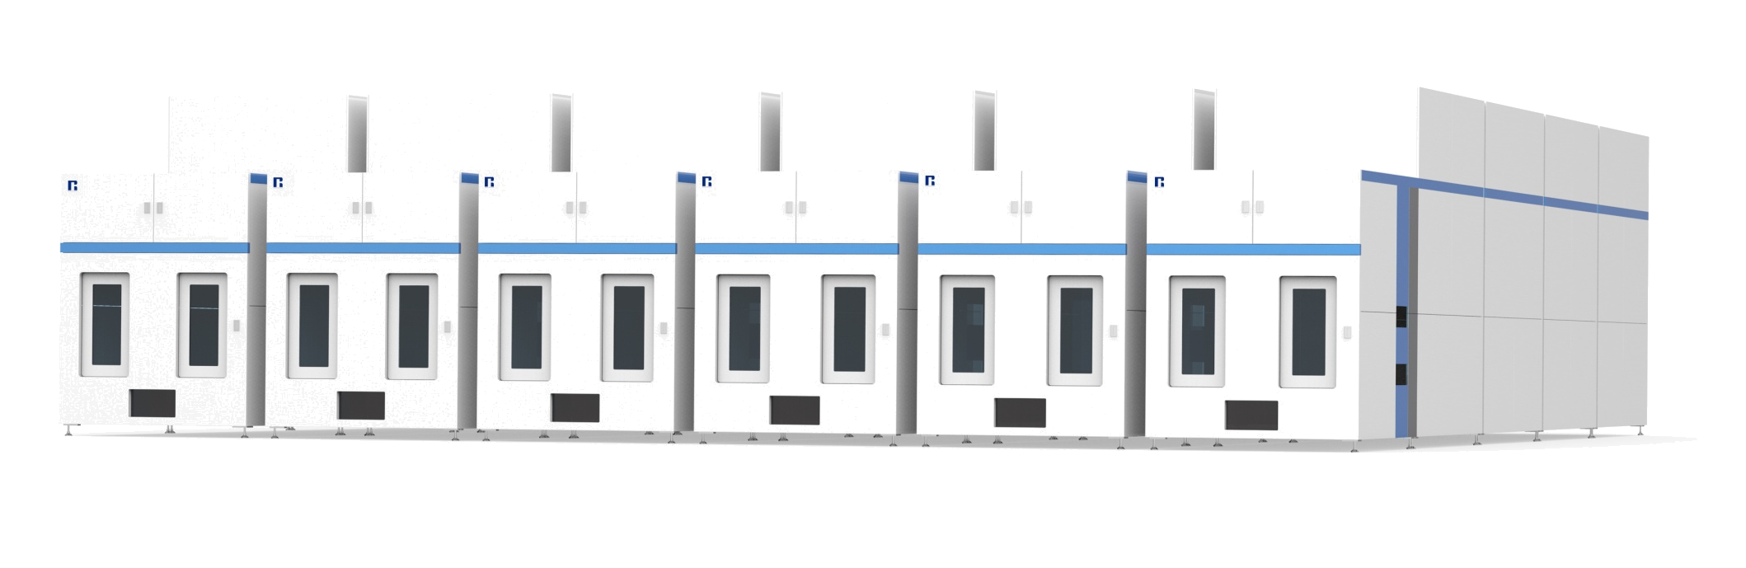
Technology requirement:
Suitable Material size: 7-13’
Max weight: 2KG
Max capacity:10000 reels
Auto issue out reel base on SFMM pull list and update the data to SAP
2) Online x-ray
Machine need to be designed as module, and easy to maintenance, also must meet EHS request.
Suitable material: 7’-15’, tray
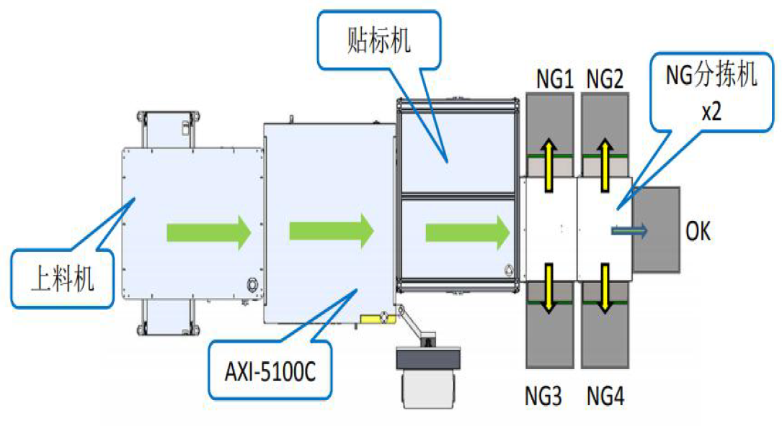
Machine list:
- Appending machine
- X-ray counting
- Labeling machine
- Sorting Conveyor
2.1 Appending machine
- Use double-station trolley
- Turnover time: ＞20min
- Auto sorting which kind of material needed to X-ray
- C/T:＜6s/pcs
2.2 X-ray counting
- Accu.＞99.6%
- C/T:＜12s/pcs
- Supplier has Safety qualification
- X-rat meet EHS request
2.3 Labeling machine
- C/T:＜12s/pcs
- According to x-ray counting data to paste QTY label

3) MSD material re-vacuuming machine
Machine need to be designed as module, and easy to maintenance, also must meet EHS request.
Suitable material: 7’-15’, tray
UPH:400 pcs/day
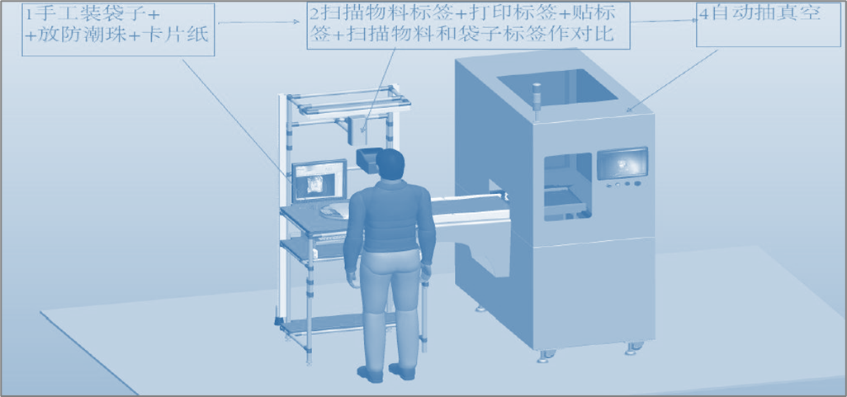
Functional requirements: photo station + online vacuum pumping;
Photo booth: can automatically press GRN, save NG photos archive. When the system comparison shows PASS correctly, the staff shall place the MSD material at the entrance of the online vacuum machine within the specified time, otherwise the equipment stops and gives an alarm, and only the foreman has the right to cancel the alarm.
On-line vacuuming: On-line inflow and outflow, that is, manually placed in the inlet, automatic inflow and self-vacuuming, and automatic outflow of the conveying line or other institutions. Do not allow employees to operate vacuum machines automatically

4) Auto slot labeling
Machine need to be designed as module, and easy to maintenance, also must meet EHS request.
Suitable material: 7’/13’
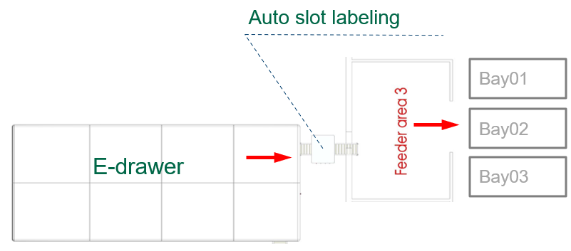

- C/T：＜10s/pcs
- Print slot label from MES system
- Adopt the online scheme, docking E-drawer

Process flow / Product info
E-drawer
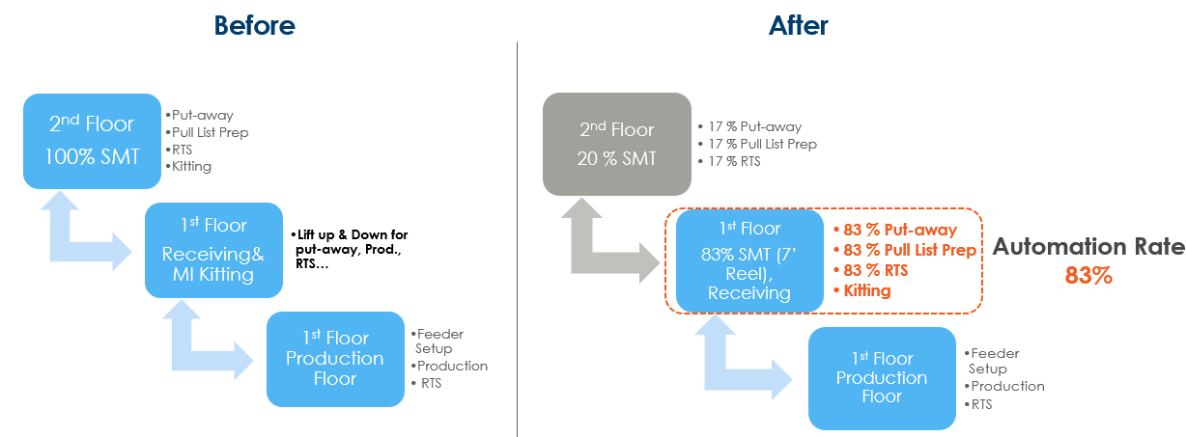
- Online x-ray
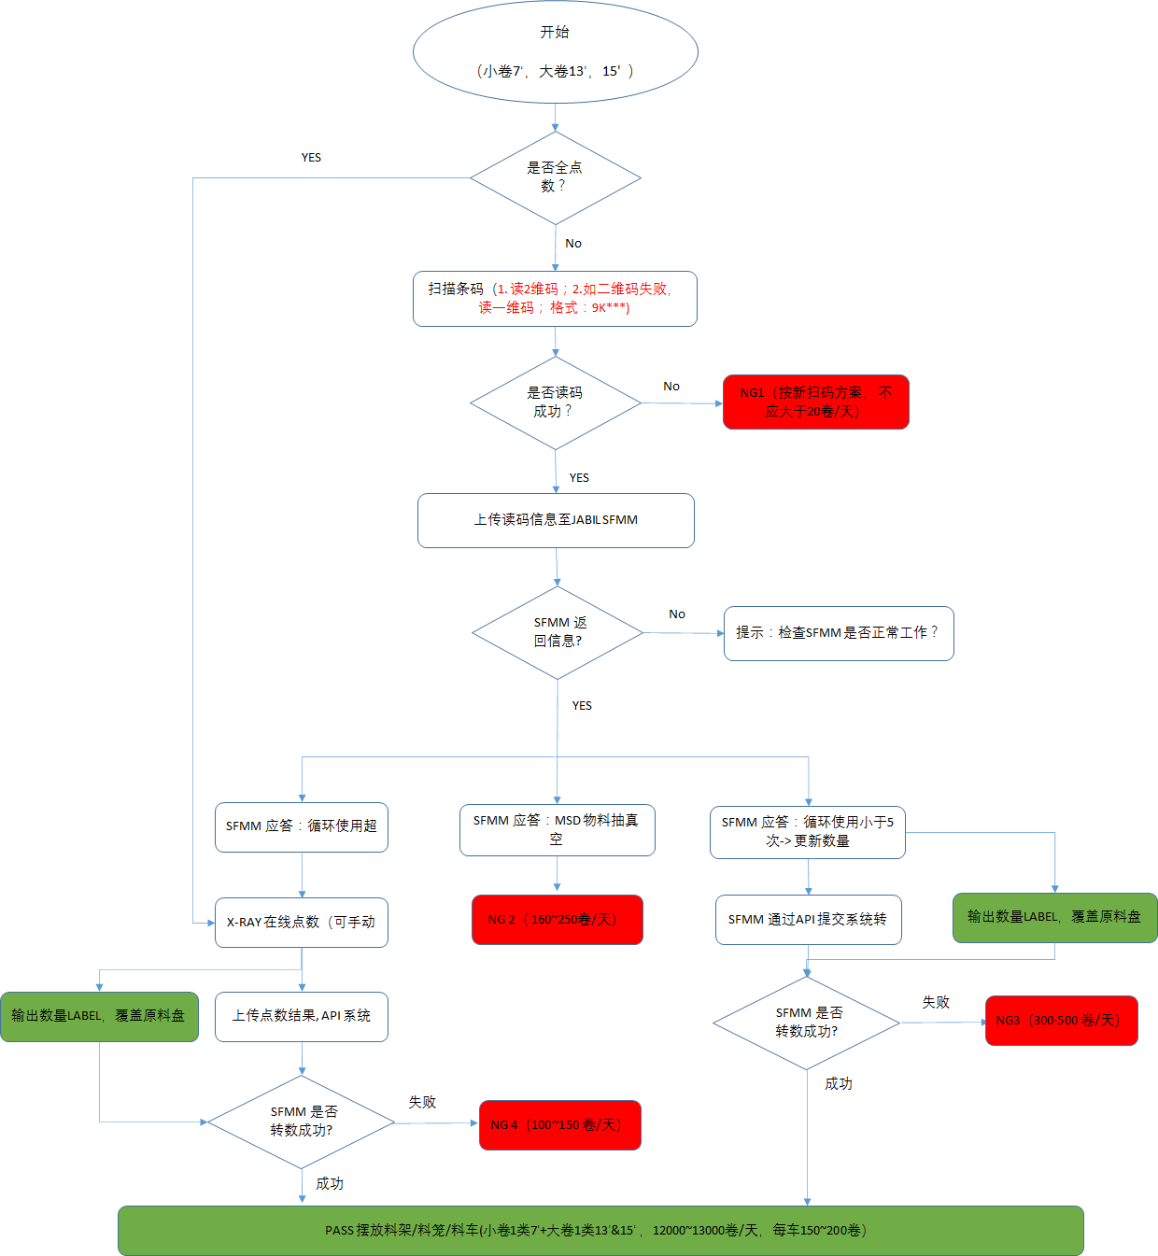
- MSD material re-vacuuming machine
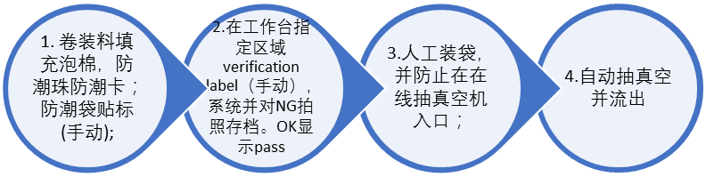
- Auto slot labeling
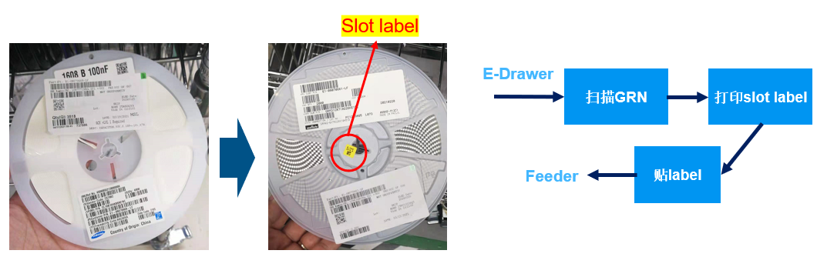

System Cycle Time
E-drawer : ＜15s/pcs
Online x-ray: ＜6s/pcs
MSD material re-vacuuming machine: ＜30s/pcs
Auto slot labeling: ＜10s/pcs

FUNCTIONAL SPECIFICATIONS

Operation modes
- Manual mode: For Programming, teaching, sub-systems manipulation, I/O status, touchup an operation
point and debug condition.
- Automated mode: Production Condition.
- Operation access levels: 2 operation levels: Operator and Administrator.

Machine Configuration

Machine must follow the general safety requirements and recommendations from site.

Air and power distribution with lock out and tag out (LOTO) feature.

E-Stop system with at least two emergencies stop buttons, one on front and one on rear.

Tamper-proof interlocks on doors.

Edge conveyor to match the reel size.

Software

2 operation access levels: Operator and Administrator.

Main application shall be designed as an “APP”, no open source code is allowed.

Connectivity to Jabil MES shop floor management system using SECS/GEM/SMEMA machine communication protocol and connectivity, necessary to drive operational efficiency and quality by means of visualization that are built to drive better shop floor efficiency.

Must to provide log files for every unit processed. Data on log file must to include: Part number, Serial number, pull list, operator, date, time and pass/fail condition.

Must to provide machine error logs. Data on log file includes: Error condition, Operator, technician, date and time.

Must to track Program or parameter setting changes.

Open code and documented, including comments.

Facilities Requirements

Footprint:

Height (max):

Weight (max): As required

Voltage: 380V AC +/- 10%

Full Load Current: 50 A

Phase: 2 Phase 3 Wire (240)

Frequency: 50 – 60 Hz

Compressed Air Flow Rate: 140 L/min Max.

Pressure: 6.2 - 6.9 bar

Application Specific Equipment

Machine Vision and Barcode System
- Top mounted camera and scanner resolution according to the inspection features needed.
- Bottom mounted camera resolution according to the inspection features needed, if required
- Optics and lighting as required.

System requirements.
- Tooling must to ensure a repeatable position of the end effector after replacement or after cleaning.
- Digital I/O is required to interface with the main controller.
- Can be operated in Automatic and Standalone mode.

Automation Guidelines
- Industrial I/O standard for communication.
- Tampered proof interlocks.
- Lock out and tag out (LoTo) features for pneumatic and electric supplies.
- One emergency stop button per operation side.
- ON button for master control relay circuit.
- Start/Stop/Reset/Home/Manual/Auto buttons.
- Light tower with colors Orange, Red and Green and buzzer for audible alarm.
- No break for local PC.

Statistics and Process data
System must to provide for display and analysis the following data:
- Machine and overall cycle time.
- First pass yield per hour, shift, week and monthly.
- Statistical Process Control (Cpk, control charts, pareto).
- System alarms and faults.
- Up and down time registering Administrator ID for any assistance.
- Operator ID check for use of authorized personnel.

General Information

Model Conversion Time.

Maximum allowance per module is 10 minutes for each real size change.

Electro Static Discharge (ESD)

Overview
The operation of any equipment will not generate unacceptable levels of static electricity through the relative motion of machine parts, the interaction of the equipment and the product, or through the interaction of the machine with plant personnel who may be expected to come in contact with the equipment during normal operation.

ESD Acceptable Levels
Acceptable level based on Jabil standards. If static electricity potentials in excess of 200V are generated by the equipment, operators, parts, or other relative movement then ESD corrective actions will be required.
    - Equipment grounding < 1 Ohm.
    - Equipotential threshold < 1 x 10⁹ Ohms (1,000 MOhms).
    - Surface static charges < 100 V.
    - All jigs, fixtures, covers must be ESD compliance.

Operation MTBF and MTTR
The system shall be capable of operating in an industrial production line atmosphere on a 24 hour / 365 day per year basis with an MTBF (mean time between failures) of no less than 2000 hours. When a failure does occur, the MTTR (mean time to repair) shall be less than 30 minutes.

Preventative Maintenance
The maximum preventative maintenance time required shall be 1/2 hour per week as performed by a skilled personnel. The control system shall include a cycle counter which can easily be displayed for proper scheduling of preventative maintenance for the equipment.

Downtime
Downtime must be < 5% of the monthly available time, excluding operation issue, material issue, wrong operation and maintenance.

Safety
The system must include proper guards to protect operators from pinch points and other areas of potential injury. For emergency situations the system must include an emergency stop switch, which immediately disconnects power/air from the system.
System must comply with Jabil standards and site specific requirements.

Factory Buy-off (prior to ship)
A buy-off checklist shall be completed and signed off by the Jabil’s Factory Automation Engineer at HUA before the cell can be shipped. The buy-off checklist shall include all functionalities check, wiring and control review, software operation and error handling test, and no-error supervised basic process run for consecutive 8 hours.

Site Acceptance Test
Upon completion of installation and startup, a formal Site Acceptance Test (SAT) shall be completed at HUA site. The site acceptance test will include a 24 hour supervised production run with the supplier’s technical team onsite, followed by a 5-day continuous production run. Parts will be supplied by operations and the equipment and process will be monitored to ensure correct operation and acceptable yield. Acceptance of the equipment will occur at the end of the acceptance test, pending positive results (equipment operating correctly and acceptable yield).

ASSUMPTIONS.
- Supplier must to provide a turn-key solution.
- Supplier will do the mechanical design for the solution and must be approved by Jabil Automation team and Requestor before start fabrication.
- Jabil Automation Team and Requestor will approve and release the design as well as the fabrication of the structure. For any impediment or restrictions seen during construction, the supplier must advice immediately to the Jabil Automation Engineer and Requestor responsible to expose the constrain and find an approval to proceed.
- Supplier will fabricate all the mechanics as well as the integration with the pneumatics, electric and sub- systems.
- Supplier will to perform the executive program for the controller.

CONTACTS
Name | Job Title | e-mail
William Wu | Sr Lean coach | William_wu3@jabil.com
Alan Wang | Lead automation | Alan_Wang2@jabil.com
Tim Yang | Senor supervisor | Tim_yang@jabil.com

PROJECT DELIVERABLES
- Meet our all requirement that we mentioned
- Lead time required: 8 to 12 weeks, including customizations.
- Efficiency greater than 98%.
- Documentation: User’s Manual, Technical Manual, Maintenance manual, Station Electric Schematic, Pneumatic Diagram. Mechanical drawings, Software program backups, Spare Part List.
- Critical spare part list, identification and supply.
- Training On site based on System Operation, Programming and Maintenance.
- Support on Site during four full weeks.
- One year of guarantee free on site’s part and labor and one-year free warranty for Software bug fix.
- Free on site or remotely support 24/7 after system acceptance. Response time within the first 12 hours. In site support to emergency responses must be 24 hours or less.
- MTTR, MTBF and MTBA for System calculation.
- Basic Components kit.
- Applications source code.

QUOTING FORMAT
Supplier must to submit the quotation with break down Costs as following indicated:
- Mechanical fabrication.
- Integration.
- Materials, electrical/pneumatic components.
- NRE.
- Labor.

